**Literature Review in ICT**

**Overview:**  
Information and Communication Technology (ICT) refers to technologies that provide access to information through telecommunications. This includes the internet, wireless networks, cell phones, computers, and other communication mediums. The literature on ICT covers a broad range of topics, often focusing on education, business, healthcare, and socio-economic development.

**Key Themes in ICT Literature:**

**ICT in Education:**

Enhances teaching and learning through e-learning platforms and digital resources.

Promotes personalized learning and global access to educational content.

Studies emphasize digital literacy, teacher training, and infrastructure challenges.

**ICT in Business:**

Drives efficiency and productivity through automation, cloud computing, and e-commerce.

Supports data-driven decision-making and enhances communication.

Research highlights the role of ICT in innovation and competitive advantage.

**ICT in Healthcare:**

Enables telemedicine, electronic health records, and health information systems.

Improves access to care in remote areas and supports data analytics for public health.

Literature often discusses privacy, security, and ethical issues.

**Digital Divide and Access Issues:**

Focuses on disparities in access to ICT due to geography, income, or education.

Suggests policies and initiatives to bridge the gap and promote digital inclusion.

**Emerging Trends and Technologies:**

Covers Artificial Intelligence, the Internet of Things (IoT), 5G, and blockchain.

Analyzes their potential impact on various sectors and societal transformation.

**Challenges Identified:**

Infrastructure limitations in developing countries.

Cybersecurity threats and privacy concerns.

Need for policy frameworks and regulations.

Resistance to change and digital skills gaps.

**Conclusion:**

The ICT literature underscores its transformative impact across sectors, but also highlights the

TABLE OF CONTENT

Contents

UNIT1 IMPACT OF ICT EDUCATION 3

1. Definition of ICT 3

2. Positive Impacts of ICT on Education 3

3. Challenges of ICT in Education 4

4. Examples of ICT Use in Education 4

5. Conclusion 4

**Definition of a Computer** 5

**In simple terms:** 5

**Key Functions of a Computer:** 5

**Examples of Computers:** 5

**Definition of Impact (in the context of ICT in Education)** 5

**In simpler terms:** 6

**Examples of ICT Impact in Education:** 6

1:1 Key aspect of ICT 6

1:2EXAMPLE OF ICT What is the 10 example of ICT? 7

1:3ADVANTAGE OF ICT ON EDUCATION 7

**1. Digital Divide** 8

**2. High Costs** 8

**3. Lack of Training** 8

**4. Cybersecurity and Privacy Concerns** 9

**5. Overreliance on Technology** 9

**6. Content Quality and Relevance** 9

**7. Technical Issues** 9

**8. Language Barriers** 9

1:3Objective of research 9

UNIT2: ICT ON EDUCATION IN THE RWANDA 10

1:3Objective of research 10

The objective of research can be summarized in a **1:3 format** (1 main idea, followed by 3 supporting points) as follows: 10

2:1 RISK THE PERSON WHO STUDY ICT 10

2:2 ICT ON THE INDUSTRIES IN RWANDA 12

2:3 ICT's Impact on Rwandan Industries 14

2:5 Strategic Initiatives Driving ICT Integration 15

UNIT 4: ICT on Education in the World 15

4:1 Introduction 15

4:2 Global Impacts of ICT in Education 15

4:3 Examples from Different Regions 16

**1. Kigali City (Urban Area)** 16

**2. Northern Province** 16

**3. Eastern Province** 16

**4. Western Province** 16

**5. Southern Province** 17

4:4 Challenges Globally 17

4:5 Future Trends 17

UNIT5: EVIDENCE OF ICT EDUCATION IN RWANDA 17

5.1 Government Policies and Strategic Plans 18

5.2 Digital Infrastructure in Schools 18

5.3 Teacher Training and Capacity Building 18

5.4 Online and Digital Learning Resources 18

5.5 TV, Radio & Mobile Learning 19

5.6 Higher Education and Research 19

5.7 Partnerships and International Support 19

5.8 Challenges 19

9. Impact 19

**No table of contents entries found.**[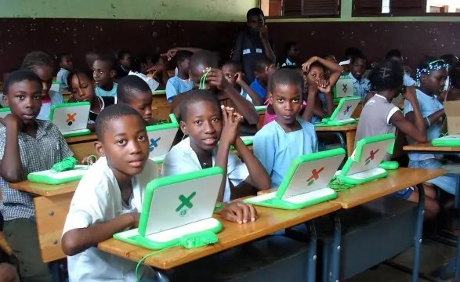](https://www.google.com/url?sa=i&url=https://umuco.centreforelites.com/the-impact-of-technology-on-education-in-rwanda/&psig=AOvVaw0J-UhcnMghomnVnNQ_nnqX&ust=1746693608062000&source=images&cd=vfe&opi=89978449&ved=0CBQQjRxqFwoTCJD7yPX6kI0DFQAAAAAdAAAAABAE)

## UNIT1 IMPACT OF ICT ON EDUCATION

### ****UNIT 1: Impact of ICT on Education****

Information and Communication Technology (ICT) has significantly transformed education worldwide, including in Rwanda. ICT tools—such as computers, the internet, digital projectors, and mobile devices—are being used to **improve the quality, accessibility, and effectiveness of teaching and learning**.

### ****1. Definition of ICT****

ICT stands for **Information and Communication Technology**. It refers to technologies that provide access to information through telecommunications. It includes tools like computers, internet, radios, televisions, mobile phones, and software applications used in education.

### ****2. Positive Impacts of ICT on Education****

#### a) **Improves Teaching and Learning**

Teachers can use multimedia (videos, presentations, animations) to make lessons more engaging and clear.

Students can learn at their own pace using e-learning platforms and educational software.

#### b) **Increases Access to Education**

Students in remote or rural areas can attend online classes and access digital content.

ICT bridges the education gap for people with disabilities through tools like text-to-speech software.

#### c) **Enhances Student Performance**

Interactive and personalized learning tools help students understand concepts better.

Online quizzes and feedback improve learning outcomes.d) **Improves School Management**

Digital systems make it easier to manage attendance, exams, and student records.

Communication between teachers, students, and parents is more efficient using ICT toolset) **Promotes Digital Literacy**

Students and teachers develop important computer and internet skills.

Prepares students for the modern workforce where ICT skills are essential.

### ****3. Challenges of ICT in Education****

**Limited access to electricity and internet**, especially in rural areas. **Lack of enough computers and equipment** in some schools.

**Insufficient training for teachers** on how to use ICT effectively.

**High cost** of devices and maintenance.

### ****4. Examples of ICT Use in Education****

**Smart classrooms** using projectors and computers.

**Online learning platforms** like Moodle and Google Classroom.

**Radio and TV lessons** broadcast during school closures.

**Digital libraries** for accessing textbooks and academic resources.

### ****5. Conclusion****

The impact of ICT on education is powerful and wide-ranging. While it brings many benefits like better access and improved learning, it also requires investment in infrastructure, training, and resources to be fully effective.

**Definition of a Computer**

A **computer** is an **electronic device** that receives data (input), processes it according to a set of instructions (called programs or software), stores the information, and produces results (output).

**In simple terms:**

A computer is a **machine that can think and work with data** — it helps people solve problems, do calculations, and perform tasks faster and more accurately.

**Key Functions of a Computer:**

**Input** – Receiving data (e.g., using a keyboard or mouse)

**Processing** – Working on the data (done by the CPU)

**Storage** – Saving data (e.g., in a hard drive or memory)

**Output** – Producing results (e.g., showing on a screen or printing)

**Examples of Computers:**

Desktop computers

Laptops

Tablets

Smartphones (also considered computers)

**Definition of Impact (in the context of ICT in Education)**

**Impact** refers to the **measurable and observable effects or changes** that result from the introduction and use of ICT (Information and Communication Technology) in education.

**In simpler terms:**

Impact means the **difference ICT makes** in how students learn, how teachers teach, and how schools operate.

**Examples of ICT Impact in Education:**

**Improved student performance** due to access to digital learning tools.

**Increased digital literacy** among students and teachers.

**Greater access to education** for remote or disadvantaged areas.

**Enhanced teaching methods**, such as using multimedia and interactive lessons.

**Faster school administration** through digital attendance, grading, and communication tools.

## 1:1 Key aspect of ICT

**INFORMATION:** The data and knowledge that is being created stored and managed.

**Communication:** is the process of sharing information, ideas, or feelings between individuals or groups.

**TECHNOLOGY:** The tools and system used to facilitate information creation storage retrieval and exchange.

1. Additional Information categories of computer hardware:

Input devices

Output devices

**2.FUNCTION OF ICT**

Network design, planning, installation and maintenance.

Software and Operating system configuration, testing, installation and support.

Changing planning, recording and management for any change to the ICT infrastructure or development environment.

ICT makes learning more interactive and engaging by facilitating the use of multimedia in teaching complex topics.

It also helps reduce the cost of education by increasing access through open educational resources.

## 1:2EXAMPLE OF ICTWhat is the 10 example of ICT?

Email

Radio

Software

Smartphone

Computer

Essential any technology that enables the creation storage and sharing information on falls under the umbrella of ICT

## 1:3ADVANTAGE OF ICT ON EDUCATION

enhancing the learning experience, promoting personalized learning, and improving communication and collaboration among students, teachers, and parents.

Engages students with multimedia tools, making learning more dynamic and enjoyable.

Reduces the need for physical materials, making education more affordable and sustainable.

Keeps educators updated with the latest teaching methods and tools through online resource

Here are some **disadvantages of ICT (Information and Communication Technology) in education Distraction and Misuse**: Students may get distracted by social media, games, or non-educational content during study time. **Digital Divide**: Not all students have equal access to devices or the internet, leading to inequality in learning opportunities. **Reduced Social Interaction**: Excessive reliance on digital learning can reduce face-to-face communication and social skills development. **Health Issues**: Prolonged screen time can lead to eye strain, poor posture, and other physical health problems. **Cybersecurity Risks**: Students and institutions may face data breaches, cyberbullying, or exposure to inappropriate content. **Overdependence on Technology**: Students might become overly reliant on digital tools, weakening their critical thinking and problem-solving skills. **High Costs**: Implementing and maintaining ICT infrastructure can be expensive for schools and families. Information and Communication Technology (ICT) has significantly transformed education, but it also presents several challenges. Here are some key challenges of ICT in education **Digital Divide Issue**: Not all students and teachers have equal access to ICT tools or the internet. **Impact**: Creates inequality in learning opportunities, especially in rural or low-income areas. **High Costs Issue**: Implementing and maintaining ICT infrastructure (computers, projectors, software, internet) is expensive. **Impact**: Limits ICT integration, especially in underfunded schools. **Lack of Training Issue**: Many educators lack the necessary ICT skills and training. **Impact**: Reduces the effectiveness of technology in improving teaching and **Cybersecurity and Privacy Concerns Issue**: Increased use of online tools raises risks of data breaches and cyberbullying. **Impact**: Threatens student safety and privacy **Overreliance on Technology Issue**: Some students may become overly dependent on digital tools. **Impact**: Can hinder critical thinking, creativity, and interpersonal skills **Content Quality and Relevance Issue**: Not all digital content is educationally sound or aligned with the curriculum. **Impact**: May confuse learners or fail to meet learning objectives **Technical Issues Issue**: Hardware failures, software bugs, and internet outages can disrupt learning **Impact**: Reduces instructional time and causes frustration.

**8. Language Barriers Issue**: Many ICT resources are available only in dominant global languages like English. **Impact**: Limits access for non-English-speaking students and teachers.

## 1:3Objective of research

The objective of research can be summarized in a **1:3 format** (1 main idea, followed by 3 supporting points) as follows **Main Objective:**  
To systematically investigate a specific problem or question to generate new knowledge or validate existing understanding.

**Supporting Objectives:** To identify patterns, relationships, or causes within the subject of study. To develop or test theories, models, or hypothesesTo apply findings for practical solutions, policy-making, or further research. Would you like this tailored to a specific field or research topic

UNIT2: ICT ON EDUCATION IN THE RWANDA

## 1:3Objective of research

## The objective of research can be summarized in a **1:3 format** (1 main idea, followed by 3 supporting points) as follows:

**Main Objective:**  
To systematically investigate a specific problem or question to generate new knowledge or validate existing understanding.

**Supporting Objectives:** To identify patterns, relationships, or causes within the subject of study.

To develop or test theories, models, or hypotheses.

To apply findings for practical solutions, policy-making, or further research.

Here's a **1:3 objective of research** focused on the impact of **ICT on education in Rwanda**:

**Main Objective:**  
To evaluate the impact of Information and Communication Technology (ICT) on the quality and accessibility of education in Rwanda.

**Supporting Objectives:**

To assess how ICT tools are integrated into teaching and learning processes in Rwandan schools.

To examine the challenges and opportunities faced by educators and students in using ICT for education.

To analyze the effectiveness of government and private sector initiatives promoting ICT in the Rwandan education sector.

## 2:1 RISK THE PERSON WHO STUDY ICT

If you're asking about the **risks faced by individuals studying ICT (Information and Communication Technology)**, here are some of the key ones:

**1. Health Risks:**

Prolonged screen time can cause **eye strain**, **poor posture**, and **repetitive strain injuries** (e.g., carpal tunnel syndrome).

Sedentary lifestyle from long hours at computers may lead to **obesity or back problems**.

**2. Cybersecurity Risks:**

Students working on networks, programming, or cybersecurity may unintentionally **expose personal data** or **become targets for cyber threats**, especially if experimenting in unsecured environments.

**3. Mental and Social Risks:**

Intense focus on technology and isolated work can lead to **mental fatigue**, **stress**, and **reduced social interaction**, potentially impacting mental well-being.

**4. Ethical and Legal Risks:**

Engaging in hacking or unauthorized access, even for learning purposes, can result in **legal consequences** if ethical boundaries are crossed.

**5. Skill Obsolescence:**

The ICT field evolves rapidly; skills learned today may **become outdated quickly**, requiring constant learning and adaptation.

## 2:2 ICT ON THE INDUSTRIES IN RWANDA

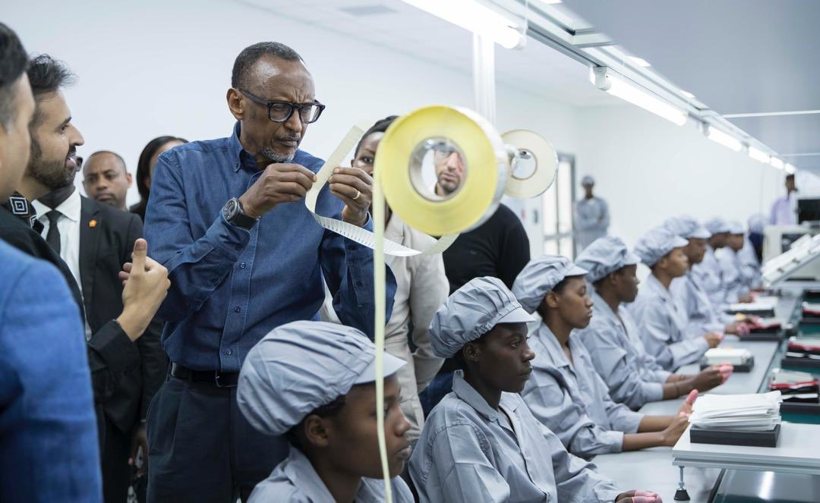

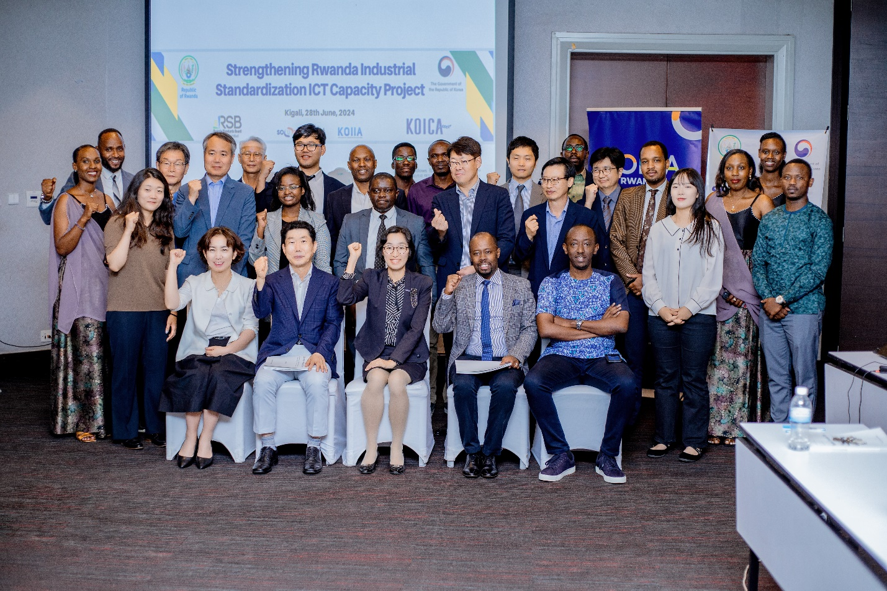

Rwanda has strategically embraced Information and Communication Technology (ICT) to transform its industrial landscape, aiming to position itself as a regional innovation hub. The government's initiatives have significantly impacted various sectors, fostering economic growth and development.

## 2:3 ICT's Impact on Rwandan Industries

#### 1. **Manufacturing and Industrialization**

The integration of ICT in manufacturing processes has enhanced efficiency and productivity. For instance, Mara Group's establishment of a smartphone manufacturing plant in Rwanda exemplifies the country's commitment to developing its tech industry and reducing reliance on imports. Such initiatives contribute to job creation and skill development in the sector.

#### 2. **Agriculture**

ICT has revolutionized the agricultural sector by providing farmers with access to real-time information on weather forecasts, market prices, and best farming practices. Mobile applications and digital platforms enable farmers to make informed decisions, leading to increased productivity and sustainability in agriculture

#### 3. **Healthcare**

The healthcare industry has benefited from ICT through the implementation of electronic health records and telemedicine services. These technologies facilitate remote consultations and efficient management of patient data, improving healthcare delivery, especially in rural areas.

#### 4. **Education**

ICT has transformed the education sector by providing digital learning tools and platforms that enhance the quality of education. Initiatives like the One Laptop per Child program and the establishment of institutions such as Carnegie Mellon University in Kigali have contributed to building a tech-savvy workforce.

#### 5. **Business and Entrepreneurship**

The rise of e-commerce and fintech solutions has empowered entrepreneurs and small businesses to reach broader markets and manage finances efficiently. Digital payment systems and online platforms have facilitated secure transactions, even in areas with limited traditional banking infrastructure.

## 2:5 Strategic Initiatives Driving ICT Integration

**Smart Rwanda Master Plan**: A comprehensive strategy outlining the country's vision for a digital economy, emphasizing e-commerce, e-governance, and ICT applications in various sectors.

**Kigali Innovation City (KIC)**: A planned 60-hectare mixed-use development in Kigali aimed at fostering innovation and technology-driven enterprises. KIC will house universities, office spaces, and startup incubators, contributing to the growth of the tech ecosystem.

**Public-Private Partnerships**: Collaborations between the government and private sector entities have led to the establishment of technology hubs and incubators, providing support and resources for startups and businesses in the ICT sector.

## **UNIT 4: ICT on Education in the World**

## **4:1 Introduction**

ICT (Information and Communication Technology) refers to digital tools and resources used to communicate, create, disseminate, store, and manage information.

In education, ICT includes tools like computers, tablets, interactive whiteboards, internet, educational apps, and learning management systems.

## **4:2 Global Impacts of ICT in Education**

**a. Improved Access to Education**

**E-learning platforms** and **online courses** enable access to education for students in remote or underserved areas.

Massive Open Online Courses (MOOCs) from platforms like Coursera, edX, and Khan Academy offer free or low-cost education globally.

**b. Enhanced Teaching and Learning**

Teachers use multimedia tools to make lessons more engaging and interactive.

ICT supports **personalized learning**, allowing students to learn at their own pace using adaptive software.

**c. Teacher Training and Professional Development**

ICT facilitates **online training programs** for teachers, helping them stay current with new pedagogies and technologies.

**d. Support for Students with Disabilities**

Assistive technologies (e.g., screen readers, speech-to-text software) help students with special needs access and benefit from education.

## **4:3 Examples from Different Regions**

Here are some **examples of ICT in education from different regions of Rwanda**, showcasing how various areas are integrating technology to improve learning outcomes:

**1. Kigali City (Urban Area)**

**Green Hills Academy** and **Lychee de Kigali** use smart boards, tablets, and virtual labs in science lessons Schools partner with tech companies to implement **coding clubs**, **robotics programs**, and **online learning portals**. The **University of Rwanda** main campus offers online registration, digital libraries, and ICT-based courses.

**2. Northern Province**

Schools in **Misanze District** have received smart classroom equipment through the **Smart Education Project**. The **Centre for Innovations and Technology Transfer (CITT)** at INES-Ruhengeri supports students with digital skills training and access to research databases. Rural schools use **solar-powered laptops and tablets** provided through international donors.

**3. Eastern Province**

In **Rwamagana**, several secondary schools benefit from government-supported computer labs and internet access. The **Digital Ambassador Program** trains teachers and students in ICT literacy. ICT is used in **vocational schools** for subjects like graphic design and computer maintenance

.

**4. Western Province**

**Nyamasheke and Rubavu Districts** have been part of the **One Laptop per Child (OLPC)** program, distributing laptops to primary students.

TVET schools in **Karongi** use computer-assisted learning for technical training, such as mechanical simulations. Radio and mobile learning is popular in areas with limited internet, especially during pandemic-related school closures.

**5. Southern Province**

Schools in **Huye** and **Nyanza Districts** are working with NGOs to introduce e-learning tools and teacher digital training. **University of Rwanda – Huye Campus** uses a blended learning approach, combining traditional teaching with digital platforms like Moodle. Primary schools receive tablets for students and laptops for teachers under Smart Rwanda initiatives. These examples show both the progress and the regional disparities in ICT integration, with urban schools generally having more resources than rural ones..

## **4:4 Challenges Globally**

**Digital divide**: Inequity in access to devices, internet, and digital skills between urban and rural or rich and poor populations. **Teacher readiness**: Many educators lack training or confidence in using ICT effectively. **One Laptop per Child (OLPC)**: Distributed over 250,000 laptops to primary school children to introduce digital literacy early. **Cybersecurity and data privacy** concerns in online learning environments.

## **4:5 Future Trends**

AI-driven education, gamification, virtual/augmented reality (VR/AR), and blockchain for credential verification are shaping the next generation of ICT in education.

## UNIT5: EVIDENCE OF ICT EDUCATION IN RWANDA

Information and Communication Technology (ICT) has played a major role in transforming Rwanda’s education system. The Rwandan government has made ICT a cornerstone of national development, especially through the **Smart Rwanda Master Plan** and the **ICT in Education Policy**. Below are key areas that demonstrate the presence and impact of ICT in Rwandan education:

## 5.1 **Government Policies and Strategic Plans**

**ICT in Education Policy (2016)**: Provides a framework for integrating ICT in teaching, learning, and administration. **Smart Classroom Project**: A government initiative to equip schools with computers, internet connectivity, and smart teaching tools. **One Laptop per Child (OLPC)**: Distributed over 250,000 laptops to primary school children to introduce digital literacy early.

## 5.2 **Digital Infrastructure in Schools** Over **1,500 schools** have been connected to electricity and internet.

**Smart classrooms** are being installed with projectors, digital boards, and computers.

## 5.3 **Teacher Training and Capacity Building**

Teachers receive training through **Continuous Professional Development (CPD)** programs to integrate ICT into their lessons. **Digital Ambassadors Program (DAP)** helps educators and local leaders improve digital skills.

## 5.4 **Online and Digital Learning Resources**

**REB E-learning Platform** offers free access to digital textbooks, lesson plans, and interactive exercises. **Cyber learning platforms** like IREMBO and eShuri allow remote access to learning materials. Universities use platforms like Zoom, Google Classroom, and Microsoft Teams for online lectures and assessments

## 5.5 **TV, Radio & Mobile Learning**

During the COVID-19 pandemic, the government used **radio and TV broadcasts** to ensure continued learning.

Mobile phones are also used to share SMS-based lessons in rural areas.

## 5.6 **Higher Education and Research**

Universities like the **University of Rwanda** have integrated ICT into teaching, administration, and research.

Students and researchers use online databases and e-libraries for academic resources.E-registration, e-examinations, and virtual labs are increasingly used.

## 5.7 **Partnerships and International Support**

Collaborations with organizations like the **World Bank**, **UNESCO**, and **Google** support ICT development in education.

International NGOs have helped fund devices, training, and digital content creation.

## 5.8 **Challenges**

Uneven access to electricity and internet in rural areasLimited digital literacy among some teachers and students.

High cost of ICT devices and maintenance.**Impact**Improved digital literacy among students and teachers.

Enhanced quality of education through access to global knowledge

**Literature Review in ICT**

**Overview:**  
Information and Communication Technology (ICT) refers to technologies that provide access to information through telecommunications. This includes the internet, wireless networks, cell phones, computers, and other communication mediums. The literature on ICT covers a broad range of topics, often focusing on education, business, healthcare, and socio-economic development.

**Key Themes in ICT Literature:**

**ICT in Education:**

Enhances teaching and learning through e-learning platforms and digital resources.

Promotes personalized learning and global access to educational content.

Studies emphasize digital literacy, teacher training, and infrastructure challenges.

**ICT in Business:**

Drives efficiency and productivity through automation, cloud computing, and e-commerce.

Supports data-driven decision-making and enhances communication.

Research highlights the role of ICT in innovation and competitive advantage.

**ICT in Healthcare:**

Enables telemedicine, electronic health records, and health information systems.

Improves access to care in remote areas and supports data analytics for public health.

Literature often discusses privacy, security, and ethical issues.

**Digital Divide and Access Issues:**

Focuses on disparities in access to ICT due to geography, income, or education.

Suggests policies and initiatives to bridge the gap and promote digital inclusion.

**Emerging Trends and Technologies:**

Covers Artificial Intelligence, the Internet of Things (IoT), 5G, and blockchain.

Analyzes their potential impact on various sectors and societal transformation.

**Challenges Identified:**

Infrastructure limitations in developing countries.

Cybersecurity threats and privacy concerns.

Need for policy frameworks and regulations.

Resistance to change and digital skills gaps.

**Conclusion:**

The ICT literature underscores its transformative impact across sectors, but also highlights the need for inclusive access, ethical considerations, and continued research to harness its full potential responsibly.